Civil war in Liberia

UNSC Resolution: | 1343
Date of adoption: | 7-Mar-2001
Operative paragraph: | 16
Demand number: | 1343,1611

Sarah-Myriam Martin-Brûlé

Wording of demand

establish Certificate of Origin regimes for the trade in rough diamonds similar to that adopted by the Government of Sierra Leone, as recommended by the Panel of Experts established pursuant to resolution 1306 (2000)

List of addressees of the demand

Government of Liberia

Short-term compliance

Description of the addressee(s)’ conduct

“10. The United Nations Office in Liberia was informed that, on 16 March 2001, a ban had been placed on the entry of all uncertified rough diamonds from countries with existing certification regimes. On 19 March 2001, the Government of Liberia unilaterally
closed its border with Sierra Leone and announced that it had since arrested seven diamond smugglers. The export of Liberia’s own rough diamonds was also
banned for a period of 120 days, pending the establishment of an internationally acceptable certification regime in Liberia. The Government contends that the second measure goes beyond the demands of the Security Council. On 21 March 2001, President Taylor wrote to the Secretary-General (S/2001/264) requesting the assistance of the United Nations. The Government of Liberia has also requested technical assistance from the High Diamond Council.”

“33. Verification of the efficacy of the banning of rough uncertified diamonds into Liberia and the 120- day suspension/banning order on the exportation of diamonds from Liberia is difficult, given the nature of the diamond trade and the high incidence of smuggling. From the documents given to the Mission by the Government of Liberia, it appeared that the government had taken more action than demanded by the Security Council in resolution 1343 (2001). Since diamonds can neither be imported into nor exported from Liberia now, it is unlikely that the smuggling of diamonds into Liberia will remain high, as profitability will plummet. Liberia’s efforts to institute its own certification of origin regime is commendable and the United Nations should help the Government to achieve its objective.”

United Nations Security Council, First report of the Secretary-General pursuant to Security Council resolution 1343 (2001) regarding Liberia. 30 April 2001

Assessment

Short-term compliance
No or marginal compliance (1) | Medium low compliance (2) | X Medium high compliance (3) | Full or almost full compliance (4)

Considerations underlying the assessment

Within the first six months after the adoption of the resolution, the Government of Liberia made significant efforts toward the establishment of a Certificate of Origin regimes for the trade in rough diamonds similar to that adopted by the Government of Sierra Leone, as recommended by the Panel of Experts established pursuant to resolution 1306 (2000).

Medium-term compliance

Description of the addressee(s)’ conduct

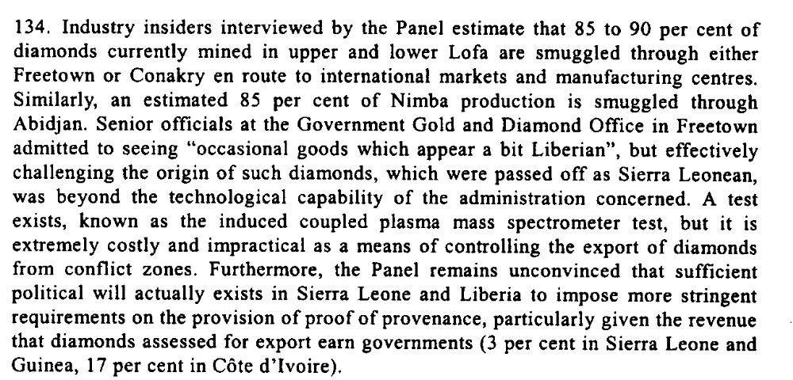
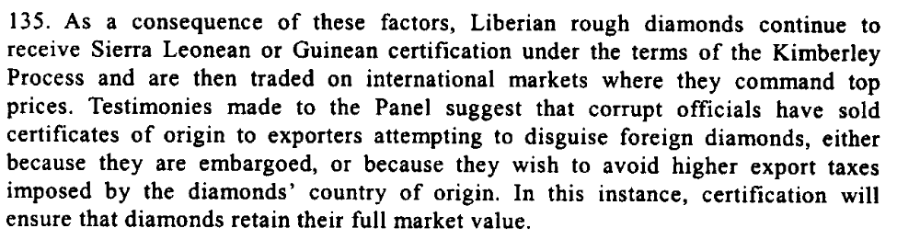
Letter dated 28 October 2003 from the Chairman of the Security Council Committee established pursuant to resolution 1343 (2001) concerning Liberia addressed to the President of the Security Council

“9. The Government’s ban on the importation of all uncertified rough diamonds from countries with certification regimes is still in force, and is beingmaintained. The ban on the exportation of Liberian diamonds also remains in full force in Liberia and
worldwide, by virtue of a public notice served to all participants in the international diamond industry, including the High Diamond Council.

10. The ban on the importation of uncertified rough diamonds and the related ban on the exportation of Liberian diamonds are being vigorously enforced by customs personnel from the Ministry of Finance and security officers of the Ministry of Justice, who are
stationed at every port of entry.

11. The Ministry of Lands, Mines and Energy has distributed to all diamond dealers in Liberia, and received acknowledgement thereof, official circulars concerning the ban on the exportation and importation of diamonds, and has established appropriate reporting
requirements on continual dealings in diamonds.

12. The Government confirms that licensed dealers are continuing to deal in diamonds, but that all diamonds bought are stored in vaults that are subject to spot inspection by inspectors from the Ministry of Lands, Mines and Energy at any time determined by
the said Ministry.

13. The Ministry of Lands, Mines and Energy has drafted a certification regime in keeping with the demands of the United Nations, and on the basis of the Kimberley process, a centralized export process is being put into place, involving the Ministry of Lands, Mines and Energy, the Ministry of Finance and the Central Bank of Liberia. The ultimate objective of this system is to enhance transparency and legitimacy in the
trade of diamonds in Liberia.”

(…)

20. The Government stated that most of the diamond-producing areas were in the combat zone in north-eastern Liberia and that it was closer and easier to get diamonds to Sierra Leone than to Monrovia. Furthermore, the Liberian economy did not have the capacity to sustain the diamond trade.

21. Independent sources indicated that there was no proof of direct importation of rough diamonds to Liberia from Sierra Leone. There was consensus that the Government of Liberia received taxes from diamond concessions but had no control over the diamond trade. Those sources indicated that there was now a reverse flow of indirect trade in diamonds from Liberia to neighbouring countries.

20. The Mission conducted interviews and held interactive sessions with government officials and other Liberians. According to the Mission, the position of the Government of Liberia with regard to paragraph 2 (a) to (e) of the resolution is that:
(c) The Government of Liberia has banned the importation of rough diamonds from Sierra Leone and has taken measures towards establishing a certificate of origin regime based on the Kimberly Process. In this regard, the Government of Liberia assured the Mission that it had banned all imports and exports of rough diamonds in its territory. The Government of Liberia, the Mission was informed, had sought financial assistance from the United Kingdom Government and the European Union. Further contacts revealed that Liberia would need about US$ 2 million to establish such a diamond certification regime. It is alleged that the process has now stalled because the High Diamond Council, which showed an initial willingness to assist Liberia, is now under unidentified external pressure not to do so. The Mission also confirmed from diplomatic sources that the Government of Liberia had made concerted efforts to ensure the establishment of a transparent and internationally verifiable certification regime. The Mission considers that Liberia needs to be assisted to meet this Security Council demand;

United Nations Security Council, First report of the Secretary-General pursuant to Security Council resolution 1343 (2001) regarding Liberia. 30 April 2001

“The committee, since 2001, had insisted that the government, especially of Charles Taylor used the precious mineral as a conduit for arms procurement to actualize his regional quest for dominance and was bent on succeeding unless the export of diamonds and timbers were sanctioned and followed up with travel ban on key officials.”

“Liberia Gets Another Chance” Global Policy Forum, March 28 2007
http://www.globalpolicy.org/component/content/article/182/33857.html

Cut off from Sierra Leone’s diamond wealth and harassed by increasingly effective Liberian dissidents now operating inside Liberia, Charles Taylor returned to his original cash cow: timber.
Ian Smilie. “Securing Sustainable Development: Trade, Aid and Security Diamonds, Timber and West African Wars”.
http://www.iisd.org/pdf/2002/envsec_diamonds_timber.pdf

Assessment

Medium-term compliance
No or marginal compliance (1) | X Medium low compliance (2) | Medium high compliance (3) | Full or almost full compliance (4)

Considerations underlying the assessment
Within the two years which followed the adoption of this resolution, the Government of Liberia made complied with aspects which were of low significance to the achievement of the objective of the demand. It is not until six years later, in 2007, that the Government succeeded in the Establishment of Certificate of Origin regimes for the trade in rough diamonds similar to that adopted by the Government of Sierra Leone, as recommended by the Panel of Experts established pursuant to resolution 1306 (2000).

Depth of demand

Assessment

Level of depth of demand
Low depth of demand (1) | X Medium depth of demand (2) | High depth of demand (3)

Considerations underlying the assessment

According to
“The committee, since 2001, had insisted that the government, especially of Charles Taylor used the precious mineral as a conduit for arms procurement to actualize his regional quest for dominance and was bent on succeeding unless the export of diamonds and timbers were sanctioned and followed up with travel ban on key officials.”
“Liberia Gets Another Chance”, Global Policy Forum, 28 March 2007.
http://www.globalpolicy.org/component/content/article/182/33857.html

Level of confidence about coding decisions

Level of confidence about coding decision
Extremely high | High | X Moderate

Comments to IPI (if any)

